|  |
| --- |
| Experiment No.6 |
| Serialization in python using Pickel |
| Date of Performance: |
| Date of Submission: |

**Experiment No. 6**

**Aim**: Serialization in python using Pickel

**Objective:** To introduce basic concept of Pickel module

**Theory**:

* What is Serialization?
* Serialization is the process of converting a Python object into a byte stream that can be stored in a file or transmitted over a network.
* What is Pickle?
* Pickle is a Python module used for serializing and deserializing Python objects.
* Why Pickle?
* Pickle provides a convenient way to save Python objects to disk and load them back into memory later.
* How to use Pickle?
* The pickle module provides two main functions: dump() for serialization and load() for deserialization.

1. **pickle.dump(obj, file)**:

* The **pickle.dump()** function is used to serialize a Python object **obj** and write it to a file specified by the file object **file**.
* This function takes two parameters:
  + **obj**: The Python object to be serialized.
  + **file**: A file object opened in binary write mode ('wb') where the serialized data will be written.

1. **pickle.load(file)**:

* The **pickle.load()** function is used to deserialize data from a file specified by the file object **file** and reconstruct the original Python object.
* This function takes one parameter:
  + **file**: A file object opened in binary read mode ('rb') from which the serialized data will be read and deserialized.

**Code:**

import pickle

# Example data to serialize

data = {'name': 'Tanishka', 'age': 20, 'city': 'New York'}

# Serialize data

with open('data.pickle', 'wb') as f:

pickle.dump(data, f)

# Deserialize data

with open('data.pickle', 'rb') as f:

loaded_data = pickle.load(f)

print(loaded_data)

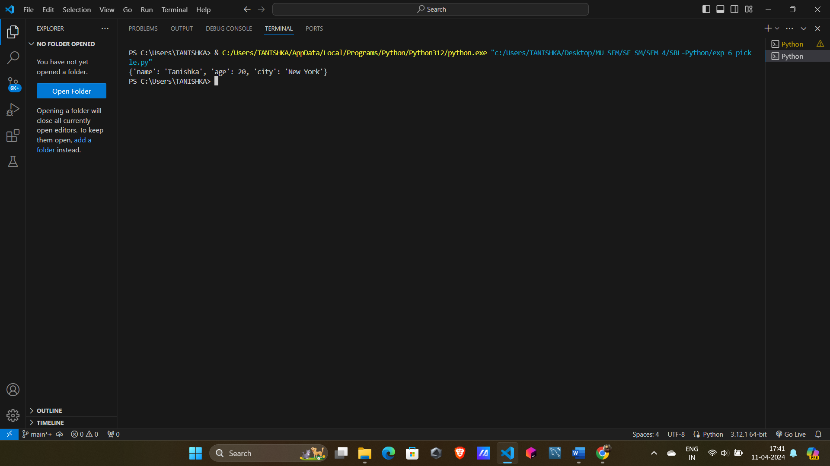**Output:**

**Conclusion:** Serialization in Python using Pickle has been demonstrated.